|  |  |  |  |  |  |  |  |  |  |  |  |  |
| --- | --- | --- | --- | --- | --- | --- | --- | --- | --- | --- | --- | --- |
| Name Song : Manyar Sewu Number of instrument : 2 | | | | | | | | | |  |  |  |
| Number of Notation : 65 Name of instrument : | | | | | | | | | |  |  |  |
| Tempo : 76 second Saron | | | | | | | | | | | |  |
| Type : Real Gamelan Peking | | | | | | | | | | | |  |
|  |  |  |  |  |  |  |  |  |  |  |  |  |
|  |  | Estimated Notation | | | | | |  |  |  |  |  |
| Notation | Original | 1 | 2 | 3 | 5 | 6 |  | Correct | Replace | Lost | Insert | Perform |
| Number | Notation (O) | 7 | (C) | (R) | (L) | (I) | (P) |
| 1 | 1 | 1 |  |  |  |  |  | 1 |  |  |  | 100% |
| 2 | 8 |  | 8 |  |  |  |  | 8 |  |  |  | 100% |
| 3 | 17 |  |  | 17 |  |  |  | 17 |  |  |  | 100% |
| 5 | 15 |  |  |  | 15 |  |  | 15 |  |  |  | 100% |
| 6 | 16 |  |  |  |  | 14 |  | 14 |  | 2 |  | 88% |
| 7 | 8 |  |  |  |  |  | 8 | 8 |  |  |  | 100% |
| sum | 65 | 1 | 8 | 17 | 15 | 14 | 8 | 63 | 0 | 2 | 0 | 98% |
|  |  |  |  |  |  |  | | | | | |  |
| Performance Evaluation | | | | |  |  |
|  |  |  |  |  |  |  |
|  |  |  |  |  |  |  |

Page 1

Original Waveform

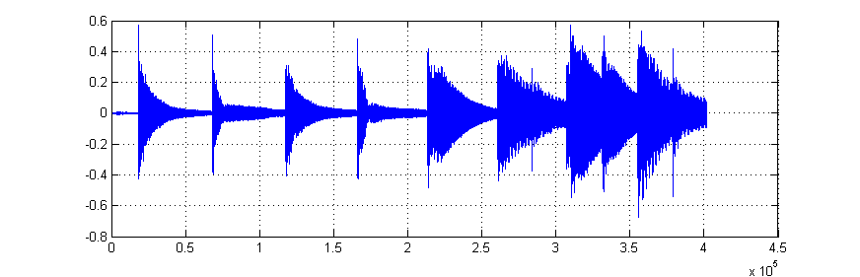

Original gamelan notation

7 6 7 6 5 3 5 3

Estimated waveform of Saron based on the template

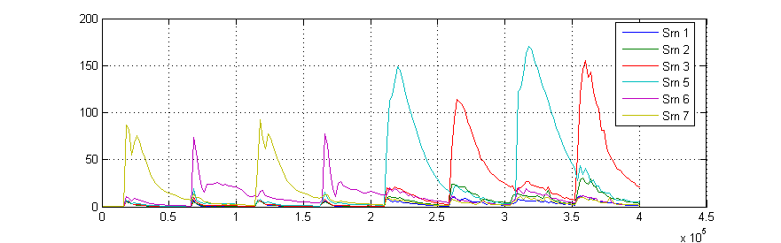

Estimated notation of Saron

7 6 7 6 5 3 5 3

Page 2

Original Waveform

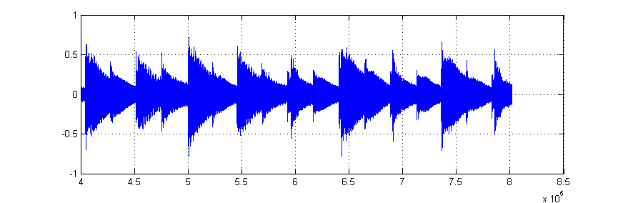

Original gamelan notation

5 3 5 3 6 5 6 5 6

Estimated waveform of Saron based on the template

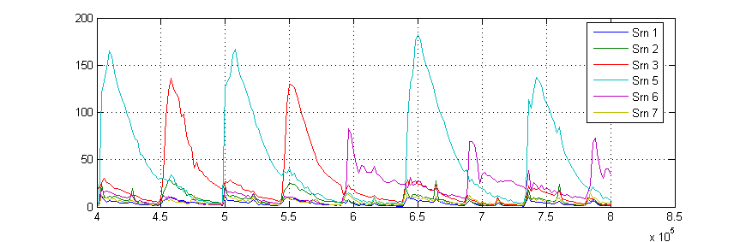

Estimated notation of Saron

5 3 5 3 6 5 6 5 6

Page 3

Original Waveform

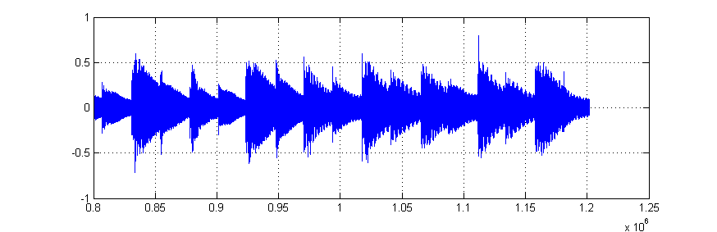

Original gamelan notation

5 6 5 3 2 3 2 3

Estimated waveform of Saron based on the template

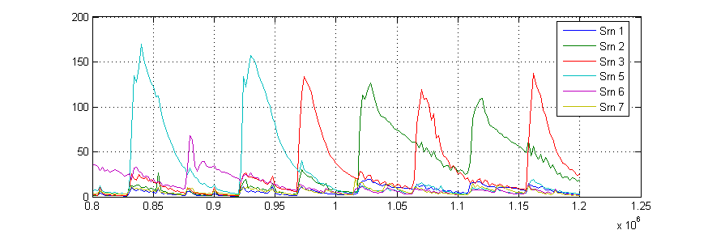

Estimated notation of Saron

5 6 5 3 2 3 2 3

Page 4

Original Waveform

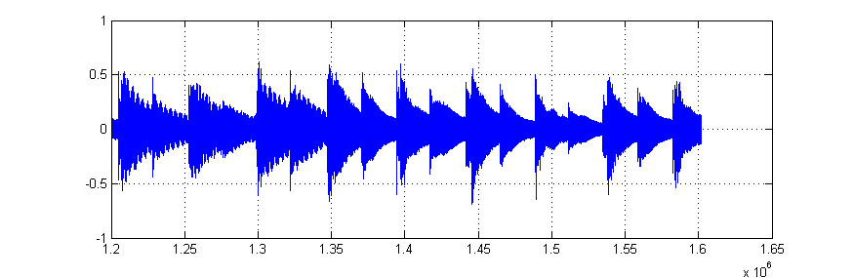

Original gamelan notation

2 3 2 7 6 7 6 7 6

Estimated waveform of Saron based on the template

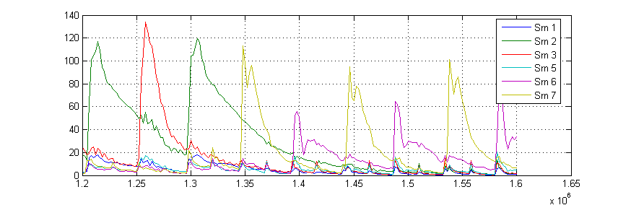

Estimated notation of Saron

2 3 2 7 6 7 6 7 6

Page 5

Original Waveform

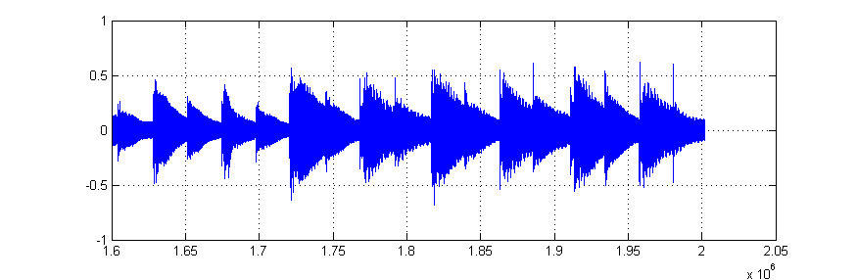

Original gamelan notation

7 6 5 3 5 3 5 3

Estimated waveform of Saron based on the template

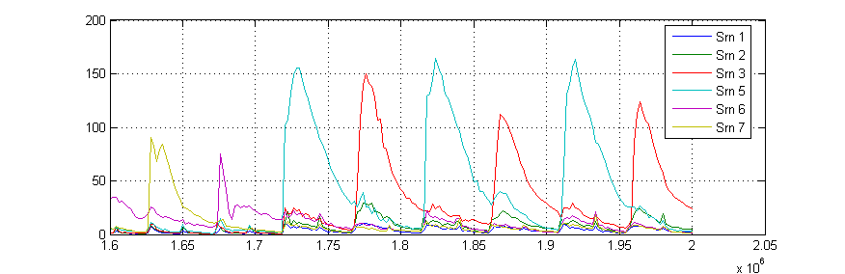

Estimated notation of Saron

7 6 5 3 5 3 5 3

Page 6

Original Waveform

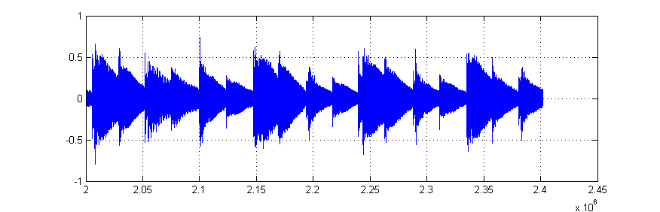

Original gamelan notation

5 3 6 5 6 5 6 5 6

Estimated waveform of Saron based on the template

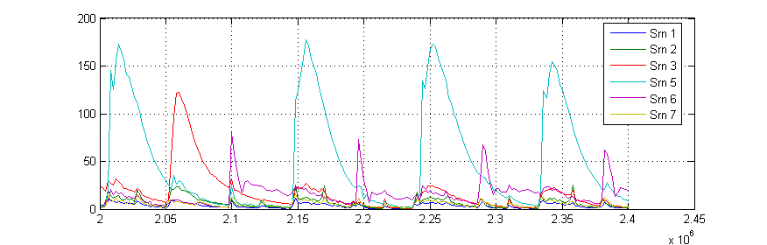

Estimated notation of Saron

5 3 5 5 6 5 6

Lost 6 6

Page 7

Original Waveform

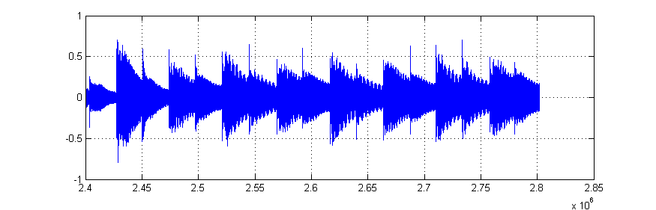

Original gamelan notation

5 3 2 3 2 3 2 3

Estimated waveform of Saron based on the template

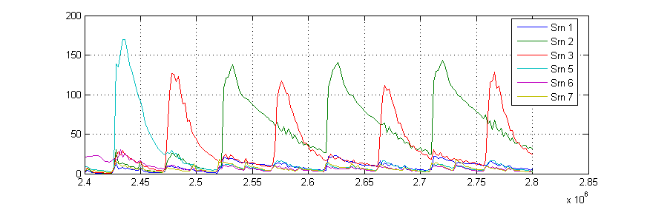

Estimated notation of Saron

5 3 2 3 2 3 2 3

Page 8

Original Waveform

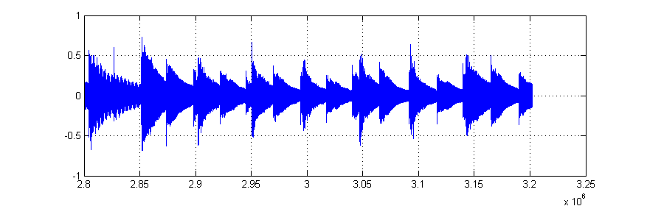

Original gamelan notation

2 7 6 7 6 7 6 5

Estimated waveform of Saron based on the template

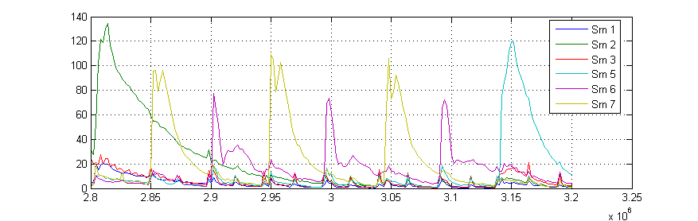

Estimated notation of Saron

2 7 6 7 6 7 6 5

Page 9

Original Waveform

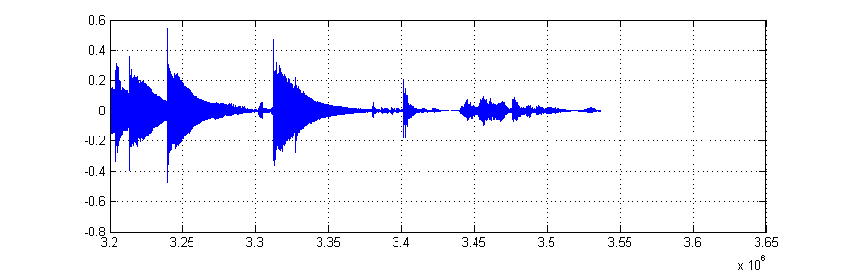

Original gamelan notation

7 3

Estimated waveform of Saron based on the template

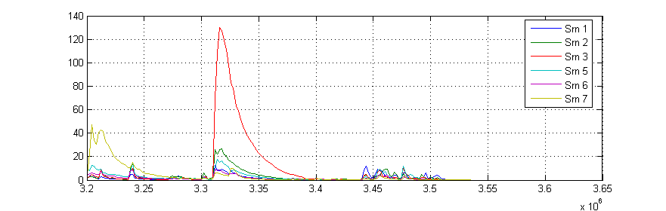

Estimated notation of Saron

1. 3